`”Car Business System” use case

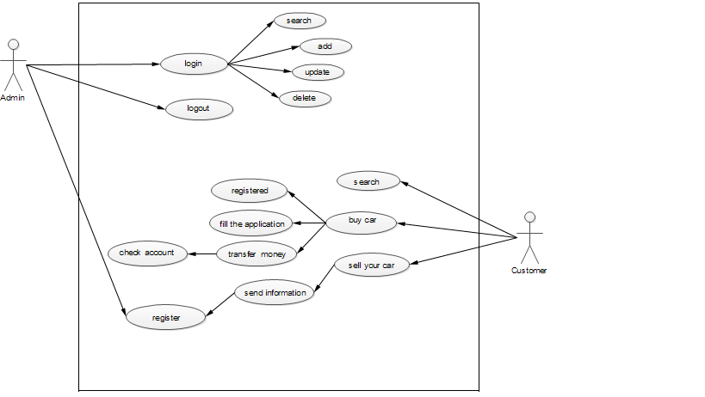

Admin is login by username and password. If admin logged in these operations are available: search, add, update, delete.

New car’s register id, mark, color, type, capacity, the manufacturer company, date and sell price etc.

Search by ID. All right update all information another from ID. /ID never changed/

Search by ID.

Search by ID. If find a result, delete with all information them. /delete only served car/

***Customer will do these operations are available: search, buy car, sell your car.***

Customer will search by car’s mark. Customer can search his interesting car.

Customer will buy his wishful car. It is possible. There are three transactions.

* Registered
* Fill the application
* Transfer money

If customer purchasing car while he will registered. While customer will fill his full name, phone number, amount, account number of costumer. Next transfer money by paypal.

If you want to sell your car, you must send your car`s application to admin. While you will send your car’s mark, color, type, capacity, the manufacturer company, date and sell price etc. Admin will decide sell or not sell them.